Python Begins here

# Python for loop

1.

p=[5,2,8]  
for x in p:  
 print ('*' * x,end =" ")  
  
2.

for x in 'piatia':  
 print(x,end=" ")  
  
3.

for x in ['pia','lomi','riata']:  
 print(x,end=" ")  
  
4.

for x in range(5):  
 print(x,end=" ")  
  
5.

for x in range(5,10):  
 print(x,end=" ")  
  
6.

for x in range(5,10,2):  
 print(x,end=" ")  
  
price=[10,20,30]  
sum=0  
7.

for x in price:  
 sum+=x  
print(sum)  
  
8.

for x in range(3):  
 for y in range (3):  
 print( f'({x},{y})',end=" ")

Ans:

1.

*****

**

********

2. p i a t i a

3. pia lomi riata

4. 0 1 2 3 4

5. 5 6 7 8 9

6. 5 7 9

7. 60

8.

(0,0)

(0,1)

(0,2)

(1,0)

(1,1)

(1,2)

(2,0)

(2,1)

(2,2)

Python Pyramids:

1.

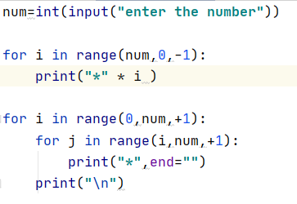

Ans:

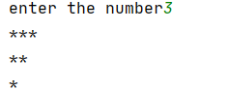



2.

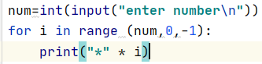

Ans:

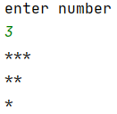

3.

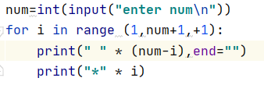

Ans:

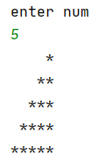

4.

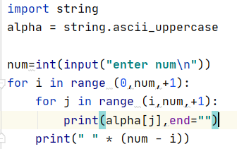

Ans:

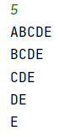

5.

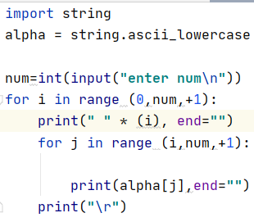

Ans:

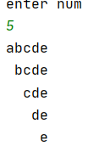

6.printing E

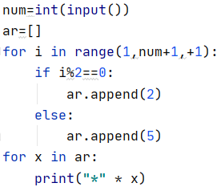

Ans:

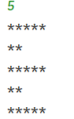

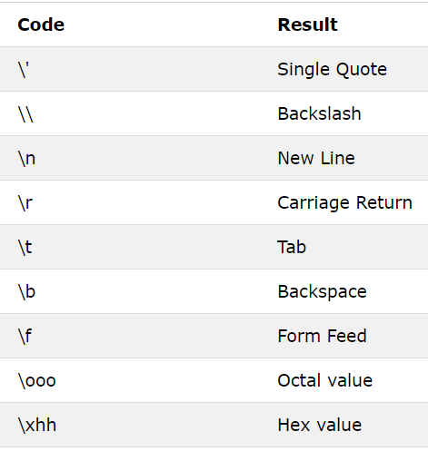

7.

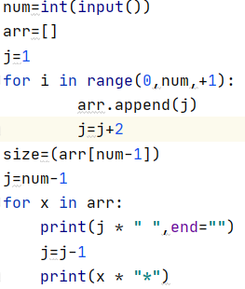

Ans:

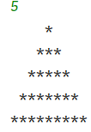

8.

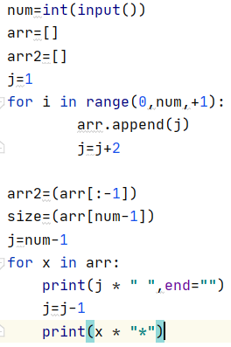

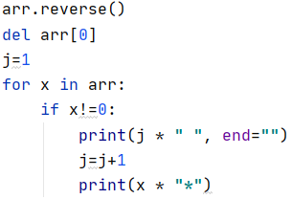

Ans

